**Loops and Iterations (5-8-2025)**

1. Write a program to print numbers from 1 to 100.

Input: take a int i as input

Process: create a gor loop for scan and printing

Output: printed number from 1 to 100

Program:

#include<stdio.h>

void main()

{

int i;

for(i=1 ;i<=100;i++)

{

printf("%d\n",i);

}

}



2. Write a program to print even numbers from 1 to 50.

|  |  |
| --- | --- |
| Input: | No user input is required |
| Process: | Loop through numbers 1 to 50 and print only even numbers (i.e., divisible by 2) |
| Output: | Displays even numbers from 2 to 50 on the screen |

Program:

#include <stdio.h>

void main()

{

int i;

for(i = 1; i <= 50; i++)

{

if(i%2==0)

printf("%d\n",i);

}

return 0;

}

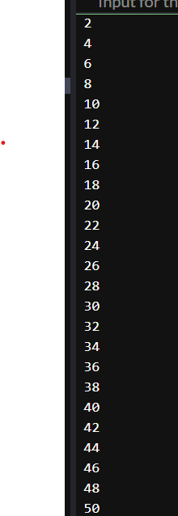

3. Write a program to find the factorial of a number.

|  |  |
| --- | --- |
| **Input** | An integer number n: entered by the user |

|  |  |
| --- | --- |
| **Process** | Multiply all integer:s from 1 to n to compute the factorial |

|  |  |
| --- | --- |
| **Output:** | Display the factorial of the entered number |
| **Program:**  **#include <stdio.h>**  **int main()**  **{**  **int i,fact=1;**  **for(i = 1; i <=5; i++)**  **{**  **fact =fact*i;**  **}**  **printf("%d",fact);**  **}** | |  |

4. Write a program to calculate the sum of digits of a number.

|  |  |
| --- | --- |
| **Input:** | An integer number n entered by the user |
| **Process:** | Repeatedly extract the last digit (n % 10) and add to sum. Then remove the last digit using n / 10. |
| **Output:** | Display the sum of the digits of the entered number |

Program:

#include <stdio.h>

void main()

{

int n,r,sum=0;

scanf("%d",&n);

while(n>0)

{

r=n%10;

sum=sum+r;

n=n/10;

}

printf("%d",sum);

}

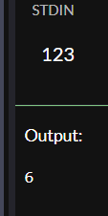

5. Write a program to reverse a number.

|  |  |
| --- | --- |
| **Input:** | An integer number n entered by the user |
| **Process:** | Repeatedly extract the last digit (n % 10) and add to sum. Then remove the last digit using n / 10.,c=100,c=c/10 |
| **Output:** | Display the reversed digits of the entered number |

Program:

#include <stdio.h>

void main()

{

int n,r,sum=0,c=100;

scanf("%d",&n);

while(n>0)

{

r=n%10;

sum=sum+r*c;

n=n/10;

c=c/10;

}

printf("%d",sum);

}

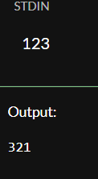

6. Write a program to check whether a number is a palindrome.

|  |  |
| --- | --- |
| **Input:** | An integer number n entered by the user |
| **Process:** | Repeatedly extract the last digit (n % 10) and add to sum. Then remove the last digit using n / 10.,c=100,c=c/10 |
| **Output:** | Display the entered number is palindrome or not |

Program:

#include <stdio.h>

void main()

{

int n,r,sum=0,c=100;

scanf("%d",&n);

while(n>0)

{

r=n%10;

sum=sum+r*c;

n=n/10;

c=c/10;

}

if(n==sum)

printf("palindrome");

else

printf("not a palindrome");

}

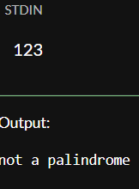

7. Write a program to print multiplication table of a number.

8. Write a program to count the number of digits in a number.

|  |  |
| --- | --- |
| **Input:** | An integer number n entered by the user |
| **Process:** | Repeatedly extract the last digit (n % 10) and add to sum. Then remove the last digit using n / 10., |
| **Output:** | Display the no of digits in entered number |

Program:

#include <stdio.h>

void main()

{

int n,r,sum=0,count=0;

scanf("%d",&n);

while(n>0)

{

r=n%10;

n=n/10;

count++;

}

printf(" no of the digit %d",count);

}

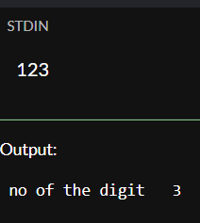

9. Write a program to print the Fibonacci series up to n terms.

Input : take input for the f and s 0,1

Process: use for loop to print the next next number

Output: Fibonacci series

Program:

#include<stdio.h>

void main()

{

int f=0,s=1,t,i;

printf("%d %d ",f,s);

for(i=1;i<=10;i++)

{

t=f+s;

printf(" %d ",t);

f=s;

s=t;

}

}

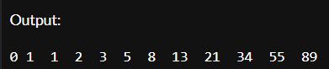

10. Write a program to calculate the sum of the first n natural numbers.

Input : no input is not required

Process: create a for a for loop and store the sum value

Output : sum of the squares of the n natural numbers

Program:

#include <stdio.h>

int main()

{

int i,sum=0;

for(i = 1; i <=5; i++)

{

sum=sum+i*i;

}

printf("%d",sum);;

}

